Combining individual MARC records into one file

MARCedit software
This step only needs to be done once after the MARCedit software has been installed.
Launch software and select the settings icon

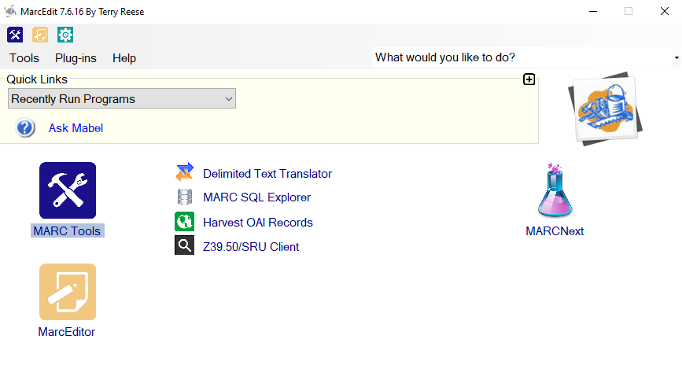
Tick MARC Join to add the icon to the home screen, click OK
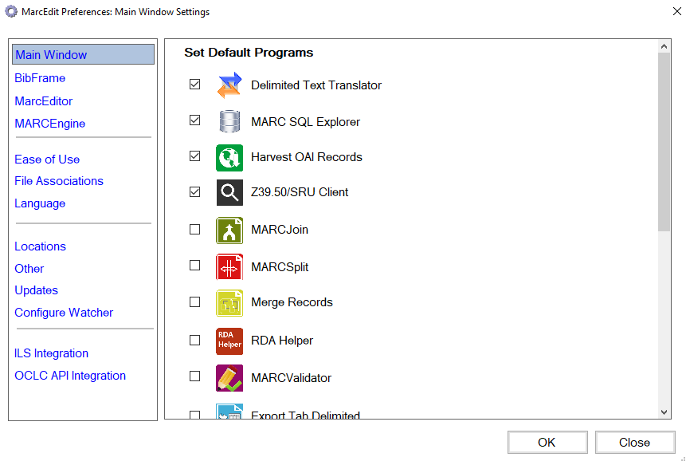

Combining individual MARC files

Select MARC Join from MARCedit’s home screen
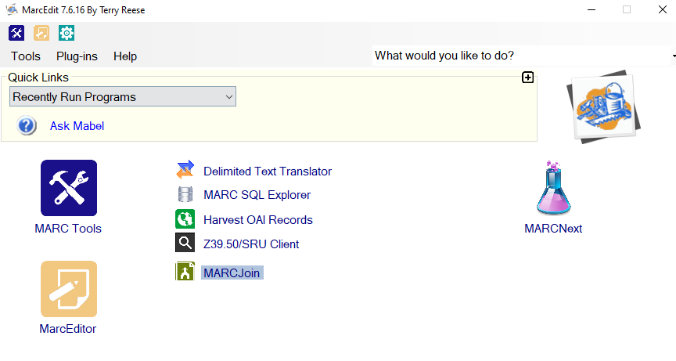
Click the folder icon next to File(s) to Join: to select the individual MARC records that you want to combine
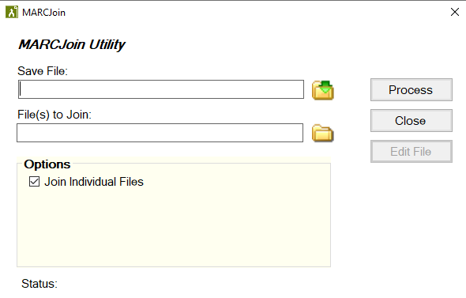

Highlight all records and click Open
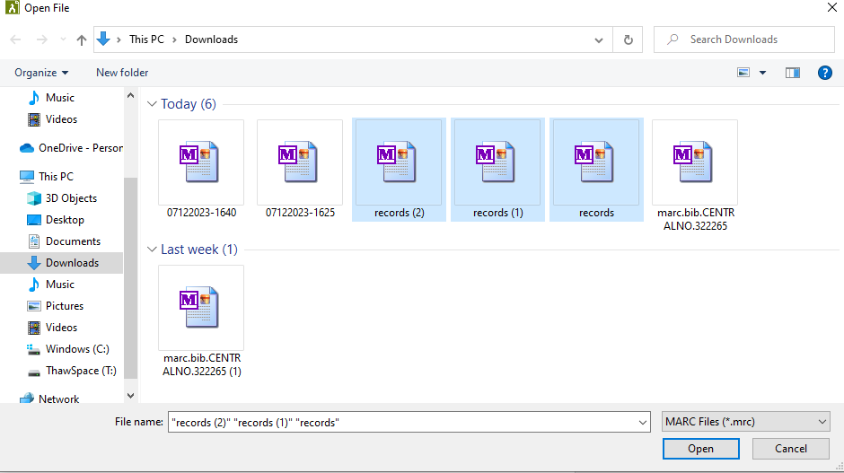

Click the folder icon next to Save File:
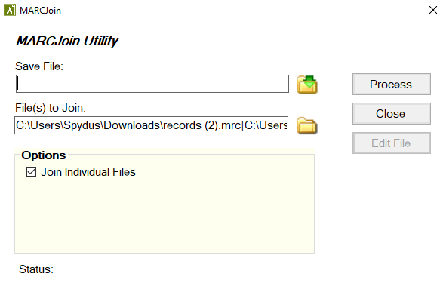
Choose the file location where you want the combine MARC records to be saves and give the file a name [ddmmyyyy-time]. Click Save.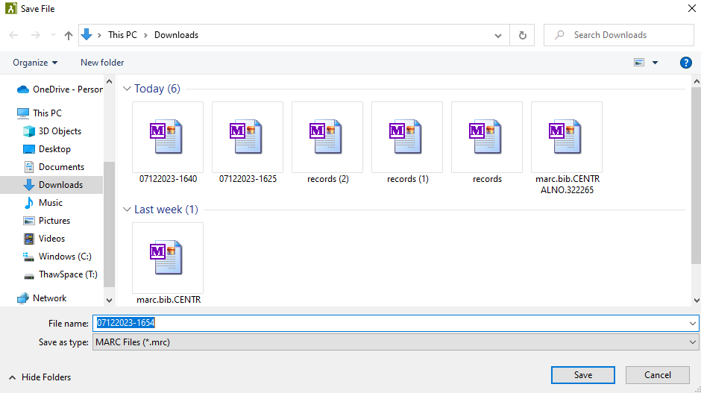

Once both sections are filled in click Process
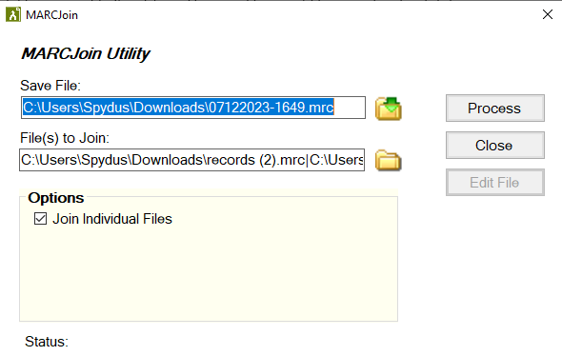

The individual files will now be combined into one and saved under the file name and location that you selected.

