Items ‘In-Transit’ from Self-Checker

If a borrower decides not to take an item they’ve loaned on the self-checkers and select the remove option on the screen, those items will be stuck In-Transit from your self-checker. You need to return these items to have their status change back to Available and allow reservations on these items to appear in your daily pick list.
To find items that may have been mistakenly put straight back on the shelf and not run through returns please follow the instruction below to generate a list for your branch.
- In the Circulation module select Search Pages > Item > Item Search
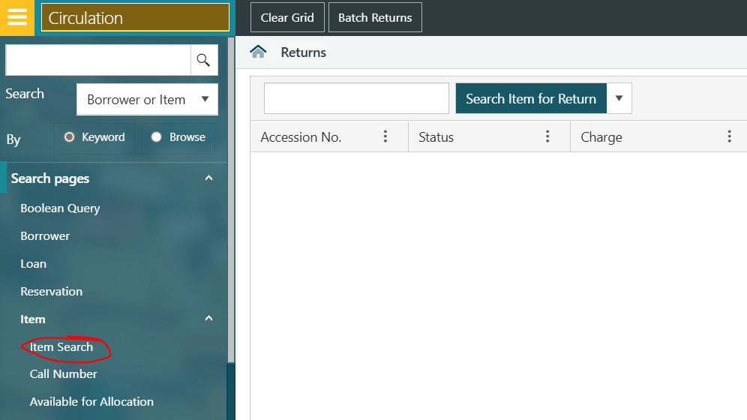
- Scroll down and select [YOUR BRANCH] Self Checker from the In-Transit From location list
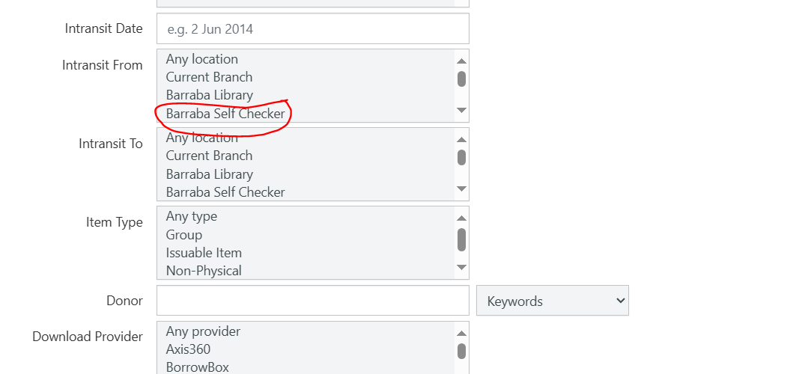
- Click Submit – you will now have a list of items that need to be run through returns

