How to search for author/title in a client’s history

- Navigate to circulation and search for the borrower number
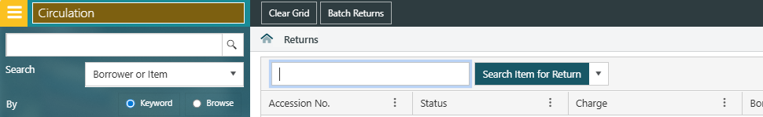

- Drop down the ‘History’ and select the loan link
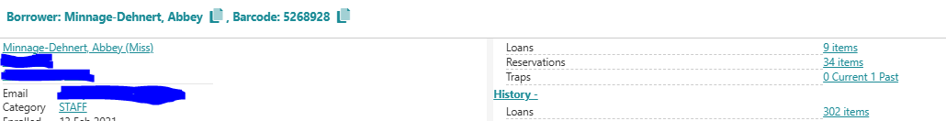

- Select ‘Translate set’ to show the bibliographic records – this will turn the results into searchable records.
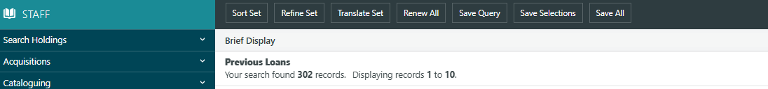
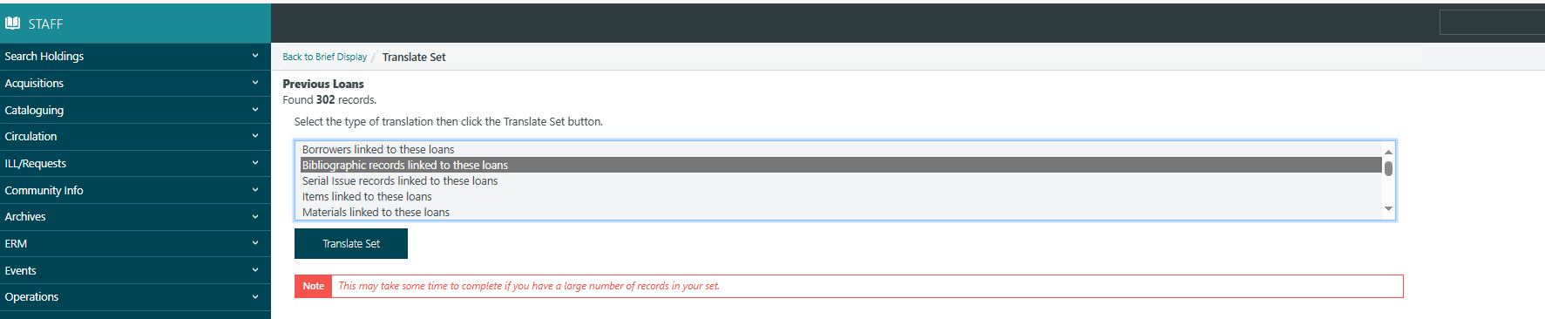

- The records are now listed in alphabetical order. Select ‘refine set’.
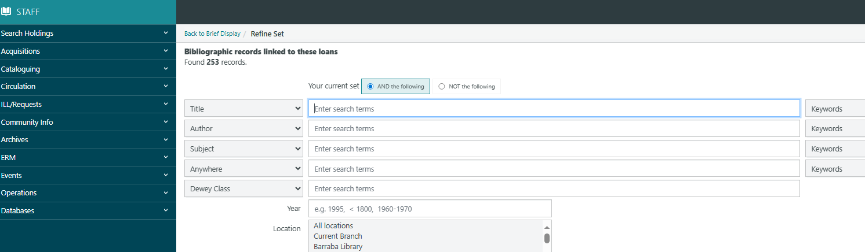

- You can now filter to find your results

