How to use the wand for stocktake
- Turn on tablet – hold in smaller button on top of the tablet
- Select Settings app (bottom middle) then ‘Network & Internet’. Connect tablet to WiFi. Select bottom circle to exit once connected
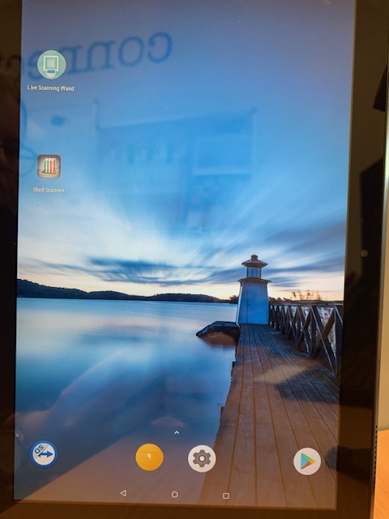

- Go to ‘Live Scanning Wand’ app

- Go to settings in bottom left corner
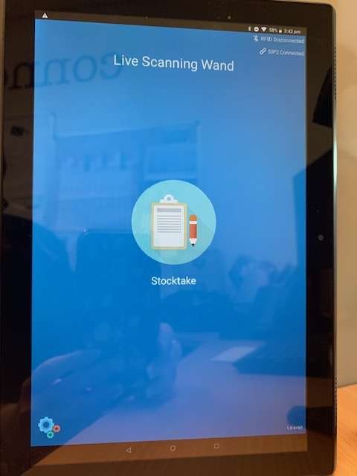

- Make sure ‘Login Location’ is changed to your branch code
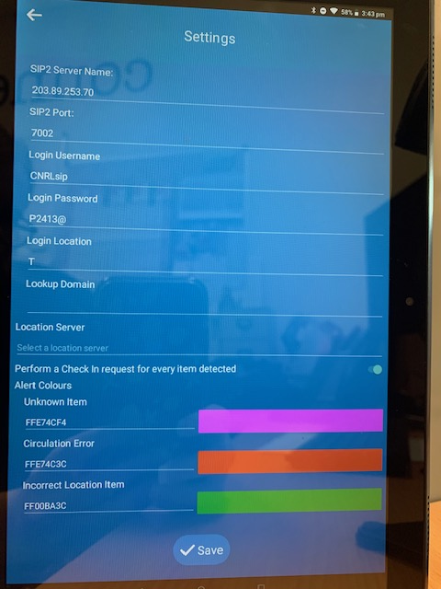
- Make sure ‘Perform a Check In request for every item detected’ is turned on (slide to the right)
- Select ‘Save’

- Turn on wand using switch on back. Make sure wand is within 1 metre of tablet.
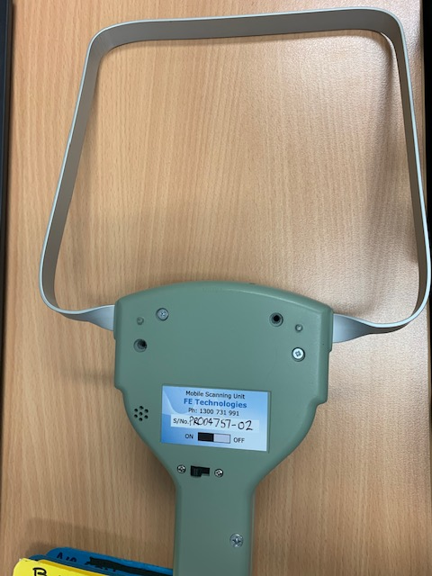

- Make sure tablet is showing status ‘RFID Connected’ and ‘SIP2 Connected’ in top right hand corner. If RFID won’t connect try switching wand off then back on
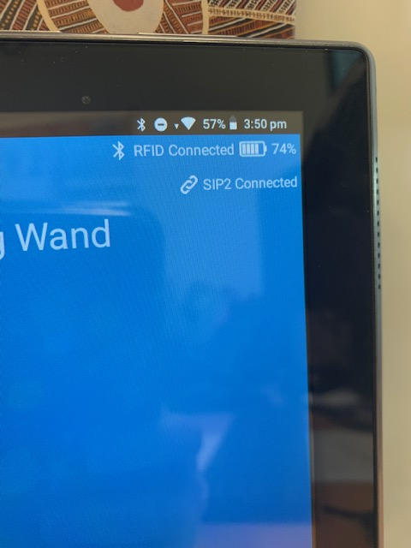

- Select ‘Stocktake’ to begin scanning items

- Press pause button in bottom right hand corner to pause then same button again to start again
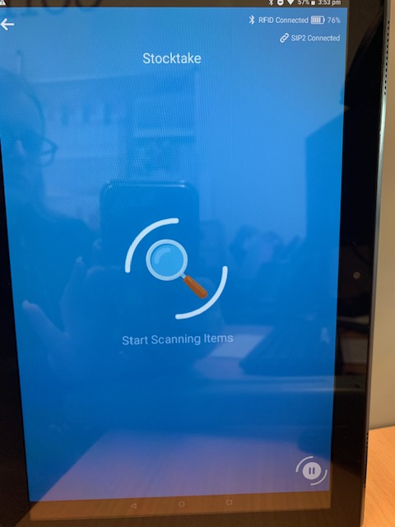
- Select arrow in top left hand corner to exit scanning mode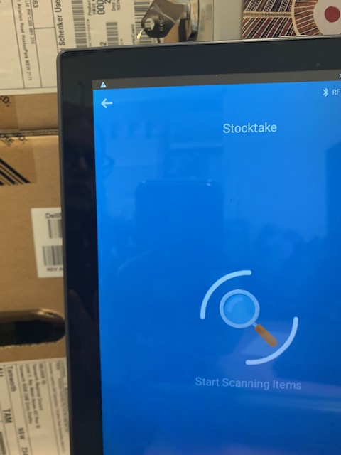

- Select circle in bottom middle to exit Live Scanning Wand

Stocktake tips
- Go slowly! If you move the wand too fast it won’t be able to process every item on the shelf
- Move items away from metal ends and book ends as the metal in these can block the wand from reading the tags
- Keep an eye on the tablet’s battery and the wand’s battery. Make sure both are charged before you start. The wand’s battery level is visible when the wand is connected to the tablet. The wand will have spare batteries in the case but please make sure you charge the used batteries when you swap them over
- If you are using the wand to look for reserved items make sure you put a ‘reservation pending’ status on those items before you start scanning

