Loading the pick list
- In Enquiry, go to the circulation drop down, ‘item’, and select ‘Available for Allocation’.
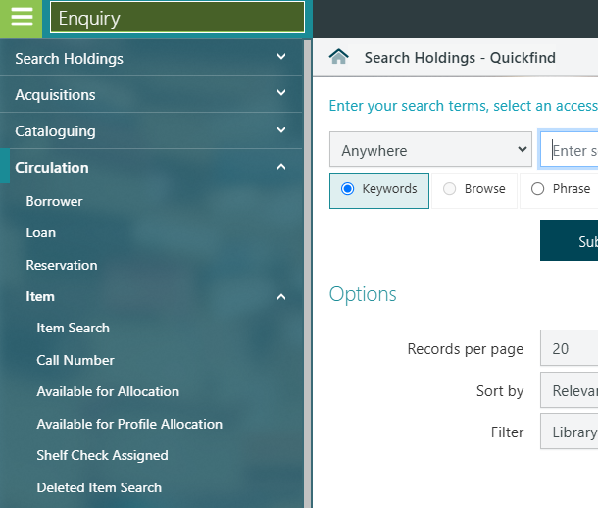

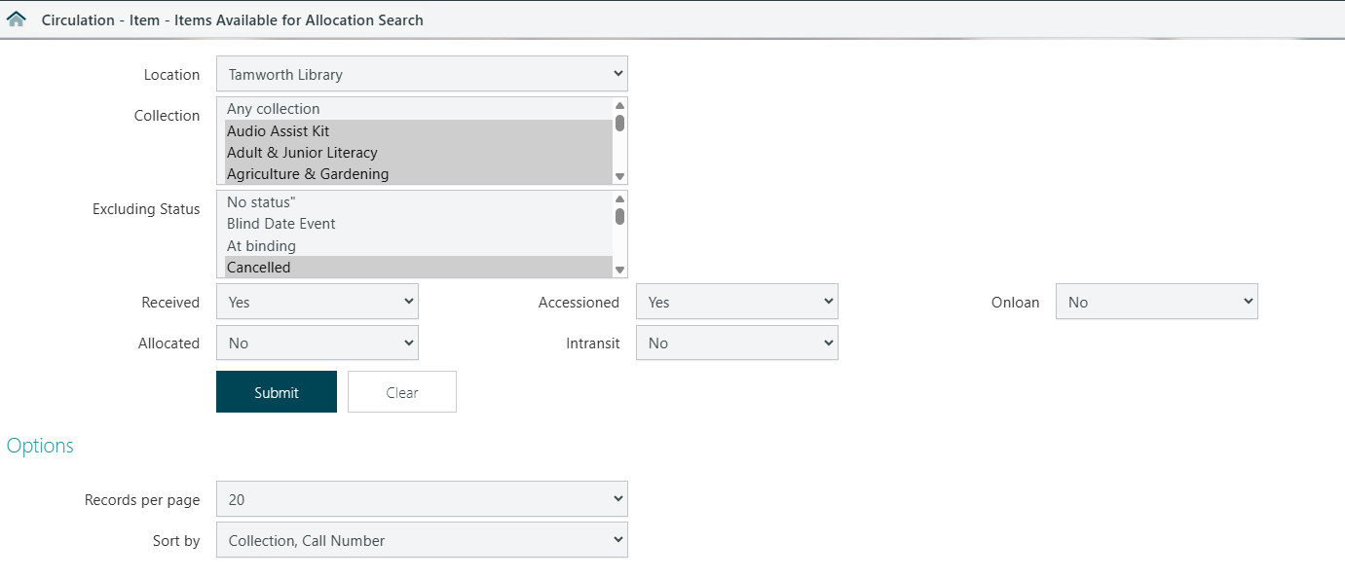
- Filter to your desired branch, transit status as ‘no’, and the recommended ‘Collection, call number’, then submit you search.

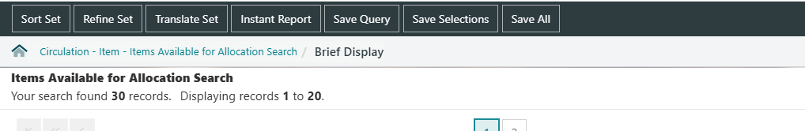
- The items on reservation will now display with linkable fields. To view the list in an easier format, select the ‘instant report’ from the top banner.

- The screen will load, then select the html link to generate the list form.
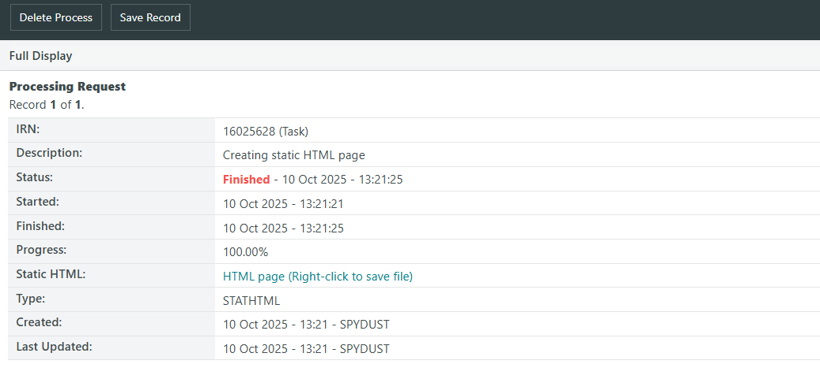

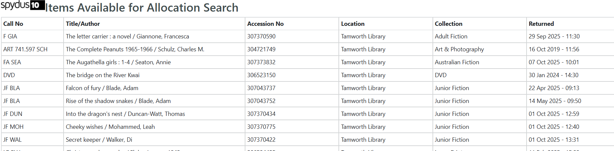

If struggling to find items on shelf, remember to check for return dates to make an informed decision about if an item is likely missing – then consider the stocktaking wand as an option to locate.

You can also use the original displayed list for locating harder to find items. You can close out of the instant report and navigate back to the brief display and select a title:
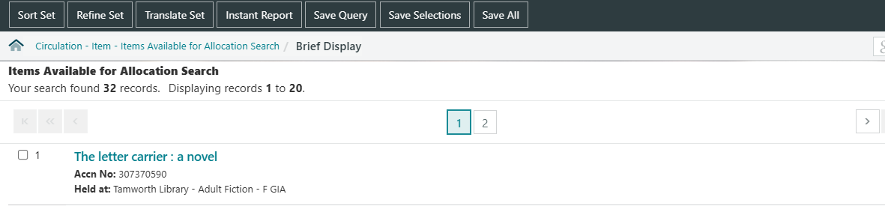

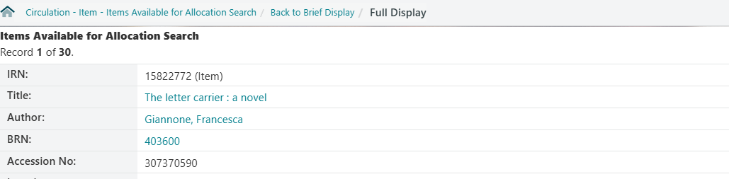

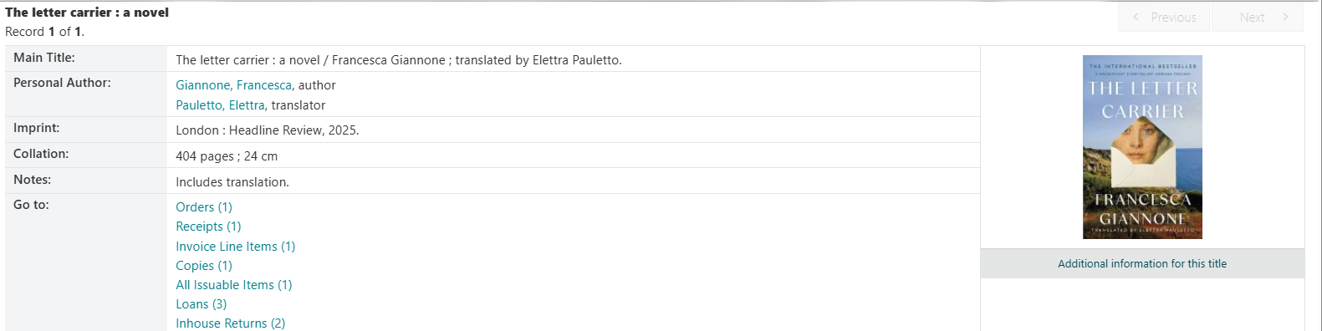

You can see the cover here (very helpful for Junior Fiction etc.), but also the year it was published – so it might be on display if in the same calendar year.

This shows it’s had a reservation pending status since 29th Sept – if it’s been 2 or 3 weeks, then it might be best to consider pushing the reservation to another branch copy, or marking as missing.

To navigate back to the brief display, use the pathways from the home icon.

