Sending bulk communications through SPYDUS

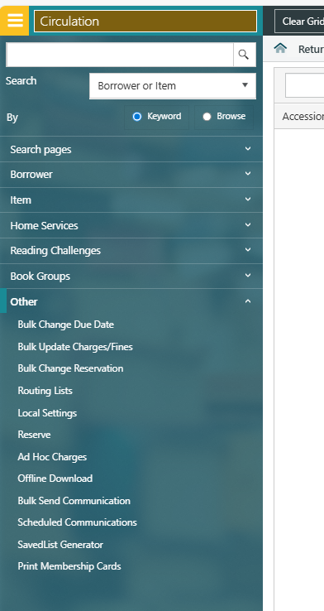
- Navigate to circulation, other, and ‘Bulk send Communication’

- Select begin searching for your group. This example is looking for an event to postpone: locate ‘events’ across the top options, and select ‘event’
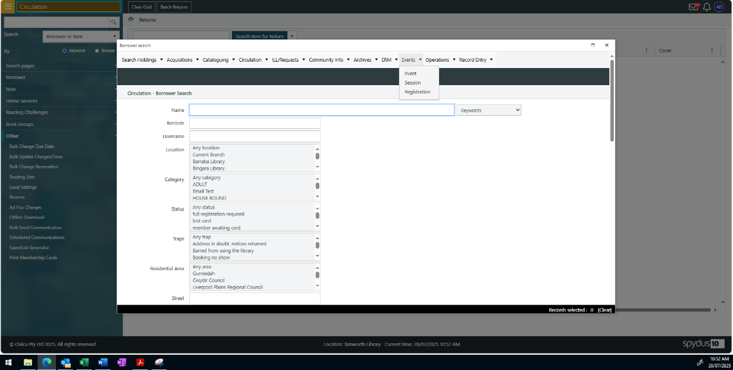

- Search for your event by title
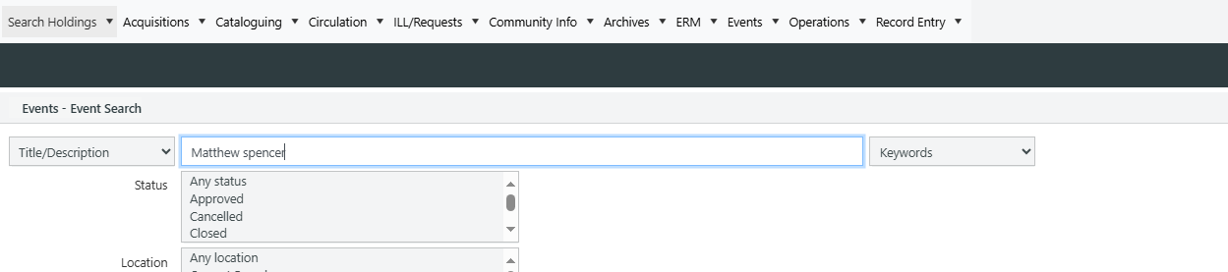

- When the event is shown, select the linking session
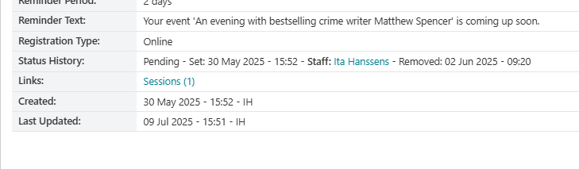

- Select the linked data with your target audience

- When your list of patrons are showing, select the set

- Your text box will then appear for you to create your message.
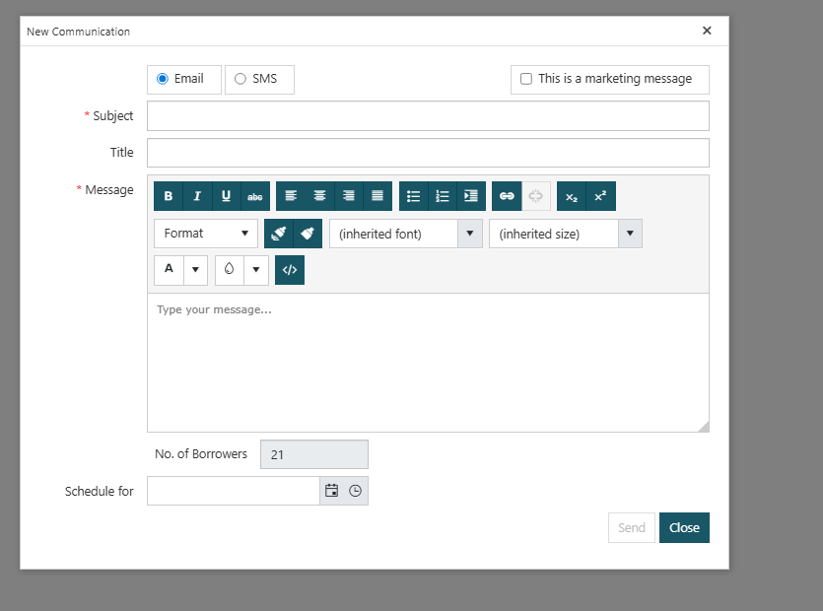

Example of what will be sent:
