Wand Setup for looking for Reservations
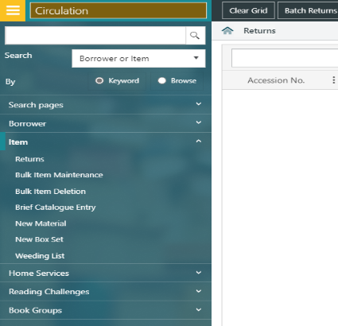
- Go to circulation > item > bulk item maintenance

- Input the criteria - item status as ‘set’ and ‘RSVP/Reservation Pending’ and tick ‘check for reservation’ then hit search.
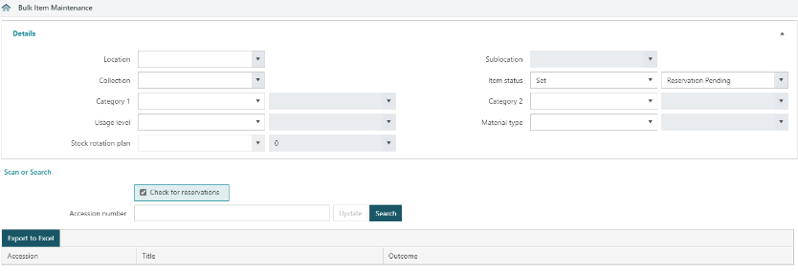

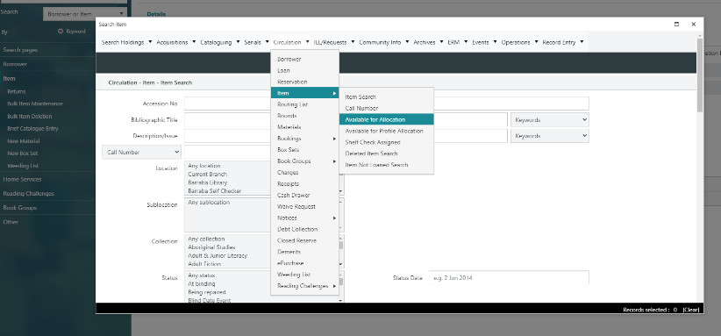
- Select criteria like you do the pick list. The tabs that are normally on the side are now across the top (Circulation, item, available for allocation etc.)
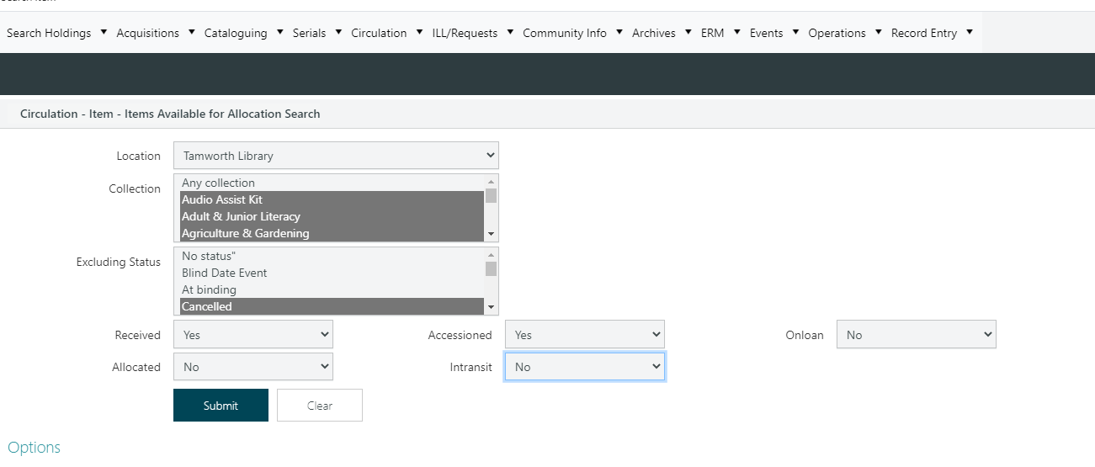

- When the list is there, hit ‘select set.’ Items should now appear in the bulk maintenance screen ready for the wand
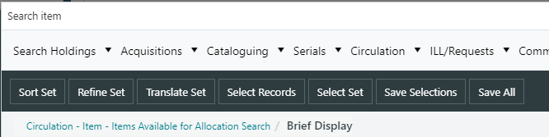

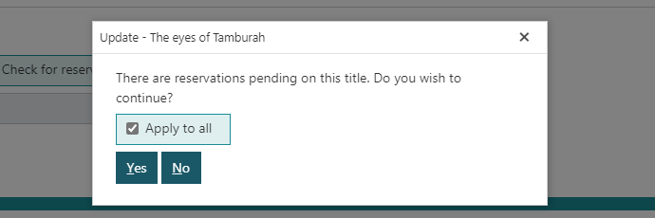
- Select ‘apply to all reservations’ and ‘yes’

- Turn on the wand iPad and open ‘live scanning wand’
- Check settings to make sure location is set to ‘T’ and > sort rules and make sure the check-in is off if you are looking for reservations.
- Check the SIP2 is connected and turn on wand for connection
- Begin the search (The stocktake button)

